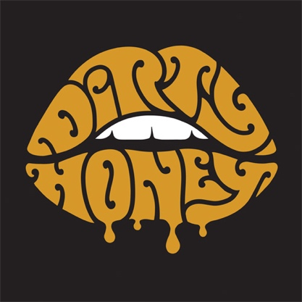

FOR IMMEDIATE RELEASE

DIRTY HONEY ANNOUNCES FALL HEADLINE TOUR
DEBUT EP TO BE RELEASED ON VINYL
INCLUDING NEW SONG, “BREAK YOU"
Debut Single, “When I’m Gone,” Claims the #3 Position at Rock Radio

LOS ANGELES, CA - Wednesday, September 18, 2019 — Armed with the #3 track at rock radio, the white-hot Los Angeles-based rock band Dirty Honey announces its first headline tour. The tour will kick off in Phoenix, AZ on Monday November 4, and take the band to nine western U.S. towns, wrapping up on November 22 at the historic Troubadour in Los Angeles. This headline run will be immediately preceded with Dirty Honey as main support for the two final dates of Guns N’ Roses “Not In This Lifetime Tour,” Friday/Saturday, November 1 & 2 at Colosseum At Ceasars Palace in Las Vegas. All dates are below; tickets are on sale now and can be purchased at https://www.dirtyhoney.com

Dirty Honey’s five song, self-titled, self-released, digital-only EP has already racked up nearly 5-million streams; tomorrow, September 19, the five tracks will be available on vinyl for the first time, plus one brand new song, “Break You.” The track was produced by Nick DiDia (Bruce Springsteen, Pearl Jam, Rage Against The Machine) and recorded at his studio in Byron Bay, Australia. The Dirty Honey vinyl EP will be available at all of the band’s upcoming tour dates, and online at www.dirtyhoney.com

As the only new, unsigned artist to debut in Rock Radio’s Top 5 in 2019, it’s already been a wild ride for Marc Labelle/vocals, John Notto/guitar, Justin Smolian/bass, and Corey Coverstone/drums. With their fresh take on southern blues, balls-out rock’n’roll and big choruses, Dirty Honey delivers dynamic live sets night after night, already earning the praise of tour mates The Who, Slash, and Guns N’ Roses.

Prior to the dates with Guns N’ Roses and the band’s headline tour, Dirty Honey will hit the road with Alter Bridge, also making stops at the Louder Than Life and Exit 111 festivals. All dates are below.

SEPTEMBER
19 The Ritz, Raleigh, NC *
21 House of Blues, N. Myrtle Beach, SC*
22 MECU Pavilion, Baltimore, MD **
24 Terminal 5, New York, NY **
25 The Met, Philadelphia, PA **
27 Express Live!, Columbus, OH **
28 Louder Than Life, Louisville, KY (GN'R, Ice Cube)
30 Rebel, Toronto **

OCTOBER
1 MTelus, Montreal **
3 The Palladium, Worcester, MA **
5 Agora Theatre, Cleveland, OH **
6 The Fillmore, Detroit, MI **
8 Myth Live, St. Paul, MN **
10 Chicago Theatre, Chicago, IL **
11 Arvest Bank Theatre at the Midland, Kansas City, MO **
13 Exit 111, Manchester, TN (Guns N' Roses)
14 The Pageant, St. Louis, MO **
16 Saenger Theatre, Mobile, AL **
17 Avondale Brewing Co., Birmingham, AL **
19 Vibes Event Center, San Antonio, TX **
20 The Bomb Factory, Dallas, TX **
22 Jannus Live, St. Petersburg, FL **
24 House of Blues, Orlando, FL **
25 House of Blues, Orlando, FL **

NOVEMBER
1 Colosseum At Caesars Palace, Las Vegas, NV (supporting Guns N' Roses)
2 Colosseum At Caesars Palace, Las Vegas, NV (supporting Guns N' Roses)
4 Rebel Lounge, Phoenix, AZ ^
5 Sister Bar, Albuquerque, NM ^
7 Jake’s Backroom, Lubbock, TX ^
9 Lost Lake, Denver, CO ^
12 The Saint, Reno, NV ^
13 Holy Diver, Sacramento, CA ^
14 Strummers, Fresno, CA ^
16 Voodoo Room @ House of Blues, San Diego, CA ^
22 The Troubadour, Los Angeles, CA ^
* Alter Bridge/10 Years
** Alter Bridge/Skillet
^ Headline

# # #

