FOR IMMEDIATE RELEASE

SLAYER'S REPENTLESS SET FOR 9/11/15 RELEASE

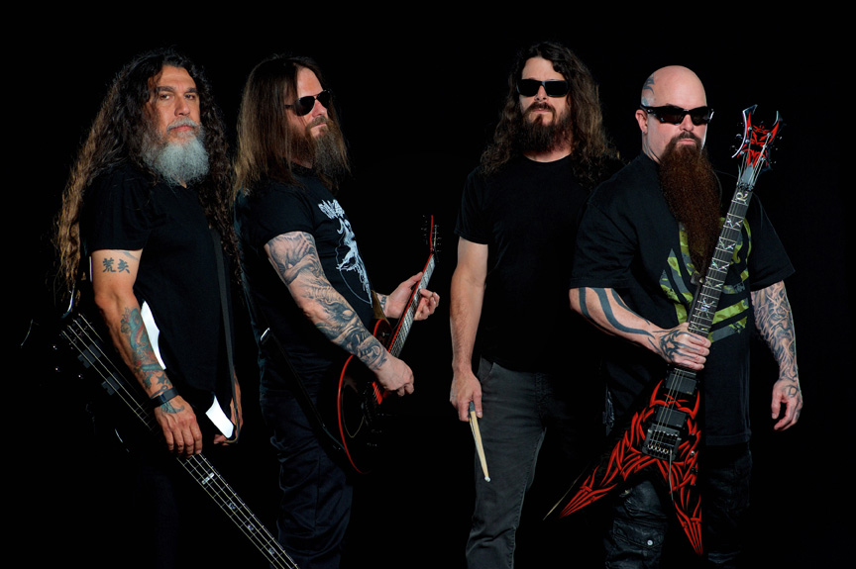

LOS ANGELES, CA - (MONDAY, August 10, 2015) - Slayer - bassist/vocalist Tom Araya, guitarist Kerry King, and returning drummer Paul Bostaph, along with touring guitarist Gary Holt and producer Terry Date - has completed recording what is one of the most highly-anticipated metal albums of 2015, and likely the most challenging album of the band's career. Repentless, Slayer's 12th studio album and the band's first new effort since 2011's Grammy-nominated World Painted Blood, will be released on September 11, 2015 (Nuclear Blast).

Slayer has already begun touring extensively to support the new album, headlining this summer's Mayhem Festival as well as playing other major outdoor festivals and several "An Evening With..." Slayer-only concerts. The confirmed itinerary is below.
Slayer has already been touring extensively to support the new album, having played major outdoor festivals, a series of "An Evening with Slayer" shows, and headlining this summer's Mayhem Festival, earning the band phenomenal live reviews:
“More than 30 years after forming, Slayer continues to deliver the show
that everybody expects while still managing to blow everybody’s mind.”
— Metal Hammer/UK

"...the quartet lived up to why its name is shouted like a mating call to get fellow headbangers pumped before a show. For an hour and 15-minutes, Slayer heavily pummeled the audience with brutal riffs that came faster, faster and faster still..."
-- Billboard

Following Slayer's studio sessions in March 2014 that yielded the track "Implode," Slayer recorded on and off between September and mid-January at L.A.'s Henson Studios. For the album, "Implode" was completely re-recorded from the ground up, and "When The Stillness Comes," used as an instrumental track in a Scion commercial, got a revamped intro and all new vocals. The 12-track Repentless is, according to those who have heard it, a sonic assault of brutal, ominous, lightening-fast and heavy-as-hell music with lyrics that unmask what Slayer knows best - the terror, the corruption and the societal turmoil that dominates our world.
"The new album sounds like Slayer," said Araya. "In the past, our fans have always known what to expect, this time they don't. But we really like it, and I don't think the fans are going to be disappointed."
The new album marks the first time Slayer has worked with producer Terry Date (Slipknot, Soundgarden, Deftones), Bostaph's return to the Slayer recording line-up since God Hates Us All (9-11-2001), and Holt's first appearance on a Slayer album. It's also the first Slayer album without the presence of founding guitarist Jeff Hanneman, athough a Hanneman-penned song is on the final track listing.
According to Araya, "Jeff had always been writing and demoing songs, even up until shortly before he passed. You can tell by the quality of his songwriting that this was his passion. There will be a song written by Jeff on the new album. Everything but the vocals had been completed, so we did the vocals and it's done. And there are a few more of Jeff's songs that we might record and release in the future."
"With this new album," added King, "Tom, Paul and I put all of our ideas out on to the table, working in a more collaborative way toward the ultimate heavy outcome. And I've got to give big props to Gary who played lead on several of the new songs. I think he got all of his leads done in one day - he's a maniac!"

ABOUT SLAYER:
For nearly three decades, Slayer's onslaught has proven the band to be the supreme thrash-metal band on the planet. The two-time Grammy-winning band has also accumulated an abundance of Certified Gold Albums along with "Best..." awards from media outlets all over the world, including Kerrang!, SPIN, Metal Hammer, Revolver, and Esquire. Throughout Slayer's history, the band has never faltered in unleashing its extreme and focused sonic assault, and, unlike many of its contemporaries who "commercialized" their sound, Slayer has remained crushing and brutal, steadfastly refusing to cater to the mainstream. Slayer's founding member, guitarist Jeff Hanneman passed in 2013, and Exodus guitarist Gary Holt has been filling in since. Paul Bostaph, who was Slayer's drummer from '94 - '01, has rejoined bassist/vocalist Tom Araya and guitarist Kerry King, and is back behind the kit. Slayer is set to release its 12th studio album later this year.

Media Contact:
Heidi Ellen Robinson Fitzgerald
herfitz@mac.com

