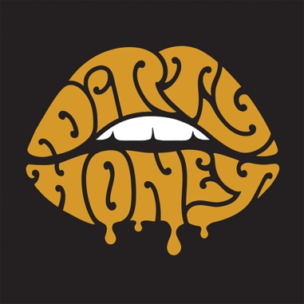

FOR IMMEDIATE RELEASE

DIRTY HONEY TO SUPPORT GUNS N' ROSES ON FINAL TWO DATES OF THE"NOT IN THIS LIFETIME TOUR"
Dirty Honey's Debut Single, "When I'm Gone,"
Now #3 on the Active Rock Radio Chart

LOS ANGELES, CA - MONDAY, September 9, 2019 - One of rock'n'roll's hottest new bands, DIRTY HONEY, has been tapped as main support for the two final dates of Guns N' Roses' "Not In This Lifetime Tour" that launched in April, 2016. The dates are set for Friday and Saturday, November 1 and 2 at The Colosseum at Caesars Palace in Las Vegas, NV.

These dates are announced just as Dirty Honey's debut single, "When I'm Gone," from the band's self-titled EP, claims the #3 position at Active Rock Radio. As NPR Music put it, "Don't believe anyone if they tell you 'rock is dead.' Dirty Honey rocks in the best possible way." Not bad for a band without a major label deal.

Before joining Guns N Roses in November, Dirty Honey will hit the road on September 19 in Raleigh, NC with Alter Bridge; all dates below.

SEPTEMBER
19 The Ritz, Raleigh, NC *
21 House of Blues, N. Myrtle Beach, SC*
22 MECU Pavilion, Baltimore, MD **
24 Terminal 5, New York, NY **
25 The Met, Philadelphia, PA **
27 Express Live!, Columbus, OH **
28 Louder Than Life, Louisville, KY (GN'R, Ice Cube)
30 Rebel, Toronto **

OCTOBER
1 MTelus, Montreal **
3 The Palladium, Worcester, MA **
5 Agora Theatre, Cleveland, OH **
6 The Fillmore, Detroit, MI **
8 Myth Live, St. Paul, MN **
10 Chicago Theatre, Chicago, IL **
11 Arvest Bank Theatre at the Midland, Kansas City, MO **
13 Exit 111, Manchester, TN (Guns N' Roses)
14 The Pageant, St. Louis, MO **
16 Saenger Theatre, Mobile, AL **
17 Avondale Brewing Co., Birmingham, AL **
19 Vibes Event Center, San Antonio, TX **
20 The Bomb Factory, Dallas, TX **
22 Jannus Live, St. Petersburg, FL **
24 House of Blues, Orlando, FL **
25 House of Blues, Orlando, FL **

* Alter Bridge/10 Years
** Alter Bridge/Skillet

