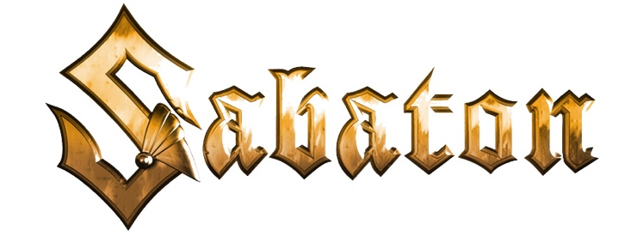

FOR IMMEDIATE RELEASE
SABATON RELEASE ITS TENTH STUDIO ALBUM
"The War To End All Wars"
New Video for New Single "Race To The Sea"
Out Today

"It's a work of art..." -- BraveWords

"...a masterclass in war history. 'Soldier of Heaven' delivers on the musical front on top of the historical one." -- Metal Sucks

"'The War to End All Wars' shows the best of both worlds: it is faithful to the classic Sabaton sound, yet it also manages to surprise even an old fan. One of their strongest works to this day." -- Inferno Magazine

"Epic choirs, wonderful guitar solos, and excellent drumming make this album another milestone on the Swedes' path." -- PowerMetal.DE

LOS ANGELES, CA -- Friday, March 4, 2022 -- Today, the eagerly awaited new studio album from Swedish war chroniclers SABATON finally sees the day of the light: The War To End All Wars is out NOW. Highly praised by international media, the tenth masterpiece of the Swedish metal force is determined to shake the world in its foundations, introducing a new era in the band's remarkable career.

Stream the album: https://music.sabaton.net/TheWarToEndAllWars
Order your physical copy: https://sabat.one/TWTEAWAlbum

The band states:
"With our last album, 'The Great War,' we found that we had only scratched the surface in terms of the powerful stories of courage and bravery and also the horrors that took place during the first World War. Fans would contact us and tell us these amazing stories from World War One that none of us had ever heard of before. Incredible, human tales like the British and German soldiers who put down their weapons on Christmas Eve in 1914 to share a moment of peace and reconciliation, right there on the battlefield; or the brave soldiers who fought in the White War, some 12,000 feet up in the Alps, who froze to death and whose bodies remain under the snow to this day. These are magnificent stories about everyday people who were willing to give their lives for something that was bigger than themselves. Marrying these true tales to loud, bruising, bone tingling heavy metal? Adding a second chapter to one the most frightening and liberating times in history? Why wouldn’t we make this album?"

To celebrate the release, SABATON releases a video for their fourth single "Race To The Sea". 'Race To The Sea' is a song about the decision from Albert of Belgium during WW1 to flood the last part of Belgium and with the help of water prevent all of Belgium to fall into German hands.

Watch the video:
https://www.youtube.com/watch?v=m-yrjYF3I8U

"Race To The Sea" is the fourth single from Sabaton's tenth album, The War To End All Wars, that is released today, March 4th, 2022 via Nuclear Blast Records. Once again, SABATON will dive deep into the atrocities, miracles and happenings around WWI and take the listener to an emotional and exciting ride of 11 tracks. "Race To The Sea" was preceded by the highly praised "Christmas Truce", the massive hit "Soldier Of Heaven" and overly popular "The Unkillable Soldier."

The War To End All Wars is available in the following formats:
- Jewelcase CD
- Limited Gold CD [Supporter Edition - various versions with translated booklets]
*SPECIAL OFFER EXPIRED* / *SOLD OUT*
- History Edition [Digibook]
- Box Set [Mailorder exclusive, 2LPs, Earbook, 5 metallic DIN A5 postcards with embossing, 1 propaganda poster]
- Earbook [ltd. to 8000 copies]
- Black Vinyl History Edition
- Copper Vinyl History Edition [Nuclear Blast Mailorder exclusive, ltd. to 500 copies] *SOLD OUT*
- Fluorescent Orange Vinyl History Edition [ltd. to 500 copies] *SOLD OUT*
- Leaf Green Vinyl History Edition [Sweden exclusive, ltd. to 300 copies]
- Fluorescent Yellow Vinyl History Edition [Ginza exclusive, ltd. to 300 copies]
- Dusk Vinyl History Edition [Levykauppa exclusive, ltd. to 300 copies]
- Soft Grey Vinyl History Edition [Nordics exclusive, ltd. 1000 copies]
- Lavender Vinyl History Edition [FNAC exclusive, ltd. to 300 copies]
- Rosewood Vinyl History Edition [Mystic exclusive, ltd. to 300 copies]
- Fluorescent Green Vinyl History Edition [UK exclusive, ltd. to 300 copies]
- Pacific Blue Vinyl History Edition [US exclusive, ltd. to 1500 copies]
- Polar White Vinyl History Edition [NB US exclusive, ltd. to 300 copies] *SOLD OUT*
- Dewdrop Vinyl History Edition [EMP exclusive, ltd. to 500 copies] *SOLD OUT*
- Green cassette [Nuclear Blast EU exclusive, limited to 100 copies] *SOLD OUT*
- Grey cassette [Nuclear Blast EU exclusive, ltd. to 100 copies] *SOLD OUT*
- Red cassette [EMP exclusive, ltd. to 300 copies] *SOLD OUT*
- Black cassette [NB US exclusive, ltd. to 200 copies] *SOLD OUT*
- Crystal Clear cassette [US exclusive, ltd. to 250 copies]
- White cassette [Mystic exclusive, ltd. to 100 copies] *SOLD OUT*

SABATON is a five-piece heavy metal band from Falun, Sweden. Since the band's formation in 1999, SABATON has achieved quadruple Platinum sales and performed colossal concerts in over fifty countries. The band's ninth studio album, "The Great War", released on July 19, 2019, is a musically rich concept album capturing the sinister atmosphere of World War I – thus continuing the band's trademark style of telling unforgettable stories from merciless battlefields all over the planet. Sabaton, signed to the world's biggest heavy metal label, Nuclear Blast Records, played "The Great Tour" at major European festivals, and throughout North America, and Eastern Europe in support of The Great War.
SABATON has put the "COVID downtime" to good use, writing, recording, and releasing a variety of stand-alone singles and music videos. The band played its first post-pandemic date on July 9, performing in front of 40,000 fans when they headlined the Exit Festival in Serbia. As you might guess... There's no end in sight for this unstoppable war machine anytime soon.

# # #

