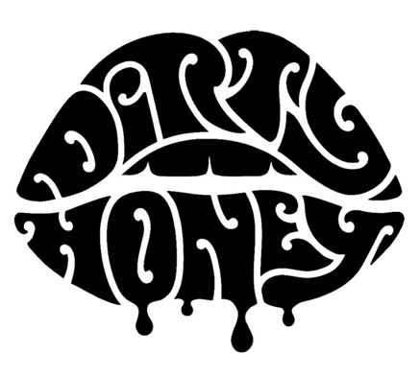

DIRTY HONEY
(Biography 2021)

Some musicians take a while to build an audience and connect with fans. For the Los Angeles-based quartet Dirty Honey, success came right out of the gate. Released in March 2019, the band's debut single, "When I’m Gone," became the first song by an unsigned artist to reach No. 1 on Billboard's Mainstream Rock chart. Their second single, "Rolling 7s," went into the Top 5 and was still headed up when COVID changed everything. That same year, Dirty Honey opened for The Who, Guns ’N Roses, Slash, and Alter Bridge and was the "do-not-miss-band" at major rock festivals such as Welcome to Rockville, Rocklahoma, Louder Than Life, Heavy MTL, and Epicenter. On its first U.S. headline tour in January and February 2020, the band sold out every date.

When it came time to record its self-titled full-length debut album, the band—vocalist Marc LaBelle, guitarist John Notto, bassist Justin Smolian, and drummer Corey Coverstone—wasn't about to mess with what was already working. Teaming up with producer Nick DiDia (Rage Against the Machine, Pearl Jam), who also produced the band's 2019 self-titled EP, Dirty Honey again captured the lightning-in-a-bottle dynamics and energy of their live sound.

"As a guitarist, I'm always inspired by the everlasting pursuit of the perfect riff," says Notto. "I also wanted to extend the artistic statement that we had already made. We weren't looking to sound different, or prove our growth, necessarily. It was more about, 'Oh, you thought that was good? Hold my beer.'"

"Because of the pandemic,” added drummer Coverstone, “we had a lot more time to write and prepare, which was great. It meant that we were able to workshop the songs a lot more, and I think it really made a difference."

Dirty Honey's album indeed builds on the band's output to date, with airtight songwriting that plays up their strengths: sexy, bluesy, nasty rock'n'roll, melodic hard rock, and soulful 70s blues-rock. On "The Wire," LaBelle reaffirms his status as one of contemporary rock’s best vocalists, while “Another Last Time” is a raunchy, timeless ballad about a toxic relationship that you just can’t stop saying goodbye to. “Tied Up” and the album’s lead single “California Dreamin,’’ both feature smoking guitar solos bookended by massive riffs and hooks.

“‘California Dreaming’ was the last song we wrote,” said bassist Justin Smolian. “We finished it about two weeks before we recorded it, so the song was still so new, and we were trying out different things, so every take was a little different. But there was that one where we just captured it, and it was magic."

Although each band member started playing music as kids—at the age of eight, Notto's parents even bought him a red-and-white Stratocaster—each one brings eclectic influences to Dirty Honey's sound. For example, drummer Coverstone has studied with jazz and L.A. session drummers but loves heavy metal; Notto grew up listening to ’70s funk and R&B as well as rock 'n' roll, and bassist Smolian has a bachelor of music in classical guitar and loves Tom Petty and The Beach Boys.

LaBelle meanwhile, takes cues from his songwriting idols (to name a few, Robert Plant, Steven Tyler, Mick Jagger, Chris Robinson, and the late Chris Cornell) when coming up with lyrics. As a result, the songs on the Dirty Honey album hint at life's ebbs and flows—shattering heartbreak, romantic connection, intense soul-searching—while giving listeners space to draw their own conclusions.

"Sometimes, if you just let lyrics pass behind your ears, they sound like cool shit is being said," LaBelle says. "And then once you dive in, you realize, 'Oh, that's really thoughtful.' But it still doesn't have a meaning that's easy to pinpoint. There's an overarching idea that is really cool, but it's not necessarily on-the-nose."

Although the Dirty Honey album may sound effortless, its genesis had a bumpy start. The day before the band members were due to fly to Australia to track the album, Los Angeles entered lockdown due to the COVID-19 pandemic, and traveling was off the table. However, Dirty Honey was still eager to work with DiDia, so they devised a Plan B: recording the full-length in a Los Angeles studio with one of DiDia's long-time engineers, and the producer beamed into the proceedings via the magic of modern technology.

"He was able to listen to what we were laying down in real-time, through this app," says LaBelle. It was like he was in the room with us. It was surprisingly seamless the way it all went down."

Having to switch gears delayed the start of recording slightly, although this extra time ended up being a boon. Dirty Honey rented a rehearsal space and demoed the album's songs in advance, meaning the tracks were in good shape when DiDia came onboard. Notto mixed and recorded these workshopped tracks himself, which helped him rediscover one of Dirty Honey's biggest strengths: being well-rehearsed while not over polishing their work.

"I've learned just a little bit more about what people might mean when they say, magic—you know, 'This one has the magic,'" he says. "We would do two and three different demos of a song, so there would be a few versions. On a few occasions, the version that people kept going back to was the sloppiest, if you look at it from a performance standpoint."

LaBelle agrees. "It's just about getting the performance right and not thinking about it too much. I never like to be perfect in the studio. None of the stuff that I really liked as a kid was. I don't really see myself getting away from that too much in the future just because I think you lose the soul if you do it too many times, if it's too perfect."

Notto also admits that the creative process isn't necessarily always all fun and games. But for him and the rest of Dirty Honey, pushing through those tough times and coming out stronger on the other side is worth it. "When you finally come through on those moments, that's where the real magic comes in," he says. "What makes all of our songs fun to play and listen to is we don't allow ourselves to stop short of getting the best possible results out of each one of them."

# # #
03.21

