x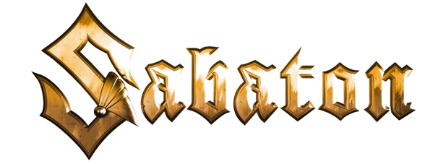

Awards, Nominations, Discography, Charts, Streams, More
8/4/21

Gold/Platinum Awards: Gold/Platinum Awards: (6 GOLD, 2 Platinum - 1 4X Platinum)
2010 - Coat of Arms - GOLD in Poland
2011 - World War Live: Battle of the Baltic Sea - GOLD in Poland
2012 - Carolus Rex - 4X PLATINUM in Sweden; GOLD in Poland
2014 - Heroes - GOLD and PLATINUM in Sweden. GOLD in Finland
2016 - The Last Stand - GOLD in Poland, Czech Republic, Sweden
2019 - The Great War – GOLD in Poland

International Chart Figures:
6 Top 5 Albums Internationally
8 Top 10 Albums Internationally
2008 - The Art of War - #5 (Sweden)
2010 - Coat of Arms - #2 Sweden, #9 Switzerland
2011 - World War Live: Battle of the Baltic Sea - #9 Poland
2012 - Carolus Rex - #2 Sweden, #7 in Germany and Poland, #9 in Finland
2014 - Heroes - #1 Sweden, #1 Finland, #1 Germany, #1 Switzerland, #6 Poland
2016 - The Last Stand - #1 Sweden, Finland, Switzerland; #2 Austria, Poland
2016 - Heroes on Tour - #8 in Germany
2019 - The Great War - #1 Sweden, Germany, Switzerland; #3 Austria, Finland, Poland; #4 Norway

Sabaton Awards and Nominations:
(5 Metal Hammer/Golden Gods Awards, including Best Live Band three different years)
2007 – Nominated for “Heavy/Power Metal” – Swedish Metal Awards
2008 – Nominated for “Best Heavy Metal” – Swedish Grammis Awards
2011 – “Breakthrough Artist” - Metal Hammer Golden Gods (UK)
2012 – “Best Live Band” – Metal Hammer Awards (Germany)
2012 – “Best Band and Best Live Band” – Bandit Rock Awards
2014 – Nominated for “Best Anthem” for “To Hell and Back” & “Best International Band” – Metal Hammer Awards (Germany)
2015 – Nominated for “Best Live Band” – Metal Hammer Awards (Germany)
2016 – Nominated for “Best Album/The Last Stand” – Metal Hammer Awards (Germany)
2017 – Nominated for “Best Anthem” for “Sparta” & “Best Live Band” - Metal Hammer Awards (Germany)

Studio Albums:
2005 - Primo Victoria (Black Lodge Records)
2006 - Attero Dominatus (Black Lodge Records)
2007 - Metalizer (Black Lodge Records)
2008 - The Art of War (Black Lodge Records)
2010 - Coat of Arms (Nuclear Blast Records)
2012 - Carolus Rex (Nuclear Blast Records)
2014 - Heroes (Nuclear Blast Records)
2016 - The Last Stand (Nuclear Blast Records)
2019 - The Great War (Nuclear Blast Records)
Compilation Albums:
2000 - Fist for Fight (Underground Symphony)
2012 - Metalus Hammerus Rex (Nuclear Blast Records)
2014 - War and Victory: The Best of Sabaton (Nuclear Blast Records)

Live Albums:
2011 - World War Live: Battle of the Baltic Sea (live)
2013 - Swedish Empire Live (Nuclear Blast Records)
2016 - Heroes on Tour (Live)

Streaming/YouTube Stats:
• More than 2-billion total streams across all streaming platforms
• 1.5-billion YouTube views

• 1.27M YouTube subscribers (8/6/21)

