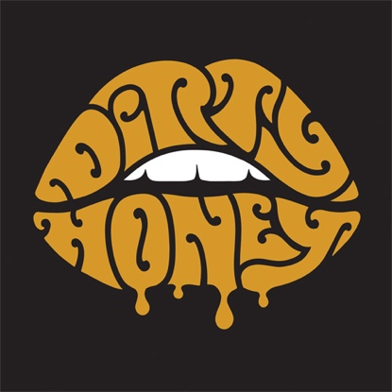

ABOUT DIRTY HONEY
The sound of Dirty Honey’s straight-up-no-apologies-no-explanations-needed music has been called "new-fashioned Rock ’n Roll.” As vocalist Marc LaBelle puts it, “We don’t want to bring anything back, we just want to make music that’s sexy and hard and rocking all at the same time.” The Los Angeles-based band - LaBelle, John Notto/guitar, Justin Smolian/bass, and Corey Coverstone/drums - has already won the praise of artists like The Who, Guns N’ Roses, and Slash, all of whom they’ve supported on tour. And Dirty Honey is 2019’s first new band to have its debut single, “When I’m Gone,” the riffy, big beat track with an instantly catchy anthemic chorus, become a Top 10 hit at rock radio. In support of its self-titled, self-released debut EP, the group tours nearly non-stop, mining its reputation as a cranking live act, in clubs, theaters, arenas, and major outdoor festivals from Welcome to Rockville, Sonic Temple and Rocklahoma to Heavy Montreal, and Epicenter. So what makes this young, still unsigned band such a force? Meaty melodies, explosive dynamics, grooves as tight as a sealed envelope, vocals that bellow across the ice and snow of Valhalla, and guitar riffs that come at you like a heavyweight haymaker. LaBelle is convinced that millennials have been starved for truly great rock music for a long time. “At some point,” he explains, “EDM and hip-hop isn’t the new thing anymore and what’s fresh again now is rock.”

Dirty Honey is both a destination and a beginning for the band. Mostly, however, it's the first of what Dirty Honey hopes will be many declarations of rock 'n' roll prowess and creative intent, forging a fresh path from familiar conventions.

# # #

8/2019

