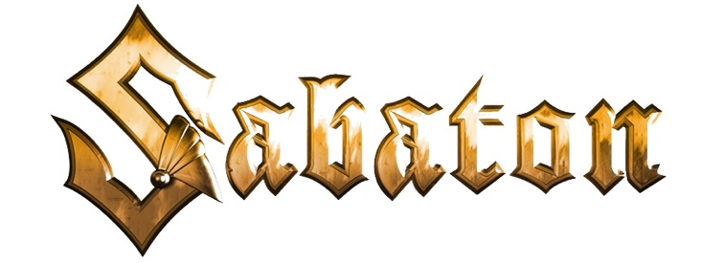

FOR IMMEDIATE RELEASE

SABATON RELEASES "STEEL COMMANDERS"
ON ALL STREAMING PLATFORMS
AND UNVEILS NEW LYRIC VIDEO FOR THE TRACK

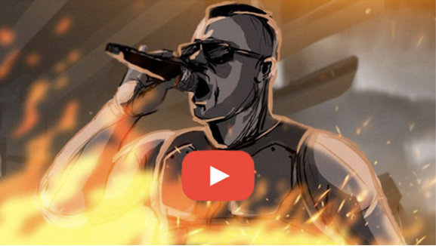

LOS ANGELES, CA - Friday, September 17, 2021 -- Swedish metal titans SABATON recently announced their new collaboration with World of Tanks and premiered a striking music video for "Steel Commanders." Pioneering hyperrealistic visuals of the band and their GRAMMY Award-nominated special guest Tina Guo in epic war scenes, the video clip was viewed more than 3.6 million times within the first three weeks of its release.

After offering fans and gamers the chance to see them as crew members on the new Strv K tank, the first-ever Tier IX premium vehicle in World of Tanks, SABATON has now answered the calls from fans asking for the song to be made available via all music streaming platforms. Hop into your tank and download or stream "Steel Commanders" here: https://music.sabaton.net/SteelCommanders

In addition, today Sabaton also releases a brand new lyric video for "Steel Commanders," inspired by the sketches used for the production of the official music video for the song. You can view the lyric video here: https://www.youtube.com/watch?v=3QRkn_lxpec

* * *

ABOUT SABATON:
In the more than two decades since their launch, Swedish metallers Sabaton have gained a legion of loyal fans across the globe by carving out a reputation as one of the hardest working bands in the business, an assessment shared by the UK's Guardian: "Other than veterans Iron Maiden, Sabaton is the biggest heavy metal band in Europe." Since the band's debut album in 2005, Sabaton has been combining standout stage design and production with epic concept albums, linking real-life historical war events with classic kick-ass metal. Sabaton has released nine studio albums, amassed six GOLD, one PLATINUM, and one four-times-PLATINUM awards, seen eight of its albums score Top 10 international chart status, and six claim the Top 5. The band has earned eight Metal Hammer/Golden Gods Awards nominations, taking home the award for "Breakthrough Artist" in 2011 and "Best Live Band" in three different years, and a Grammis nomination (Swedish equivalent to the U.S. Grammys) as Best Heavy Metal band. Sabaton has also accumulated more than two billion total streams, and 1.5 billion YouTube views.
(Continues HERE)

