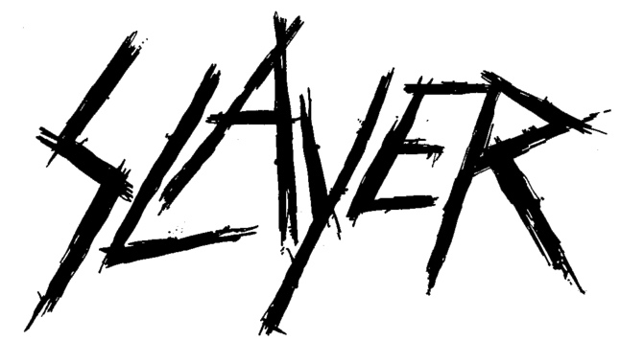

SLAYER LAUNCHES OFFICIAL THEATRICAL TRAILER FOR
"SLAYER: THE REPENTLESS KILLOGY"
WITH TICKETS ONSALE NOW
In Theaters Around The World November 6
More Info & Tickets Available at SLAYER.FILM

LOS ANGELES, CA - Wednesday, October 9, 2019 - Slayer - Tom Araya, Kerry King, Gary Holt and Paul Bostaph - along with Trafalgar Releasing, Nuclear Blast Records and Prime Zero Productions, are pleased to share the theatrical trailer for Slayer: The Repentless Killogy, coming to theaters worldwide for a one-night-only event on November 6. Check out the trailer HERE. In addition to the new trailer, fans can now find local theaters and purchase tickets at Slayer.Film

Full of revenge, murder, bloodshed and retribution, the first part of Slayer: The Repentless Killogy is a short narrative film written and directed by BJ McDonnell, that blends the music of Slayer with an uncompromising and unmissable trilogy of music videos assembled as one chronological storyline. Part two of The Repentless Killogy features Slayer's entire live set performed at the Los Angeles Forum on August 5, 2017, and was directed by Wayne Isham who has directed videos for artists including Metallica, Foo Fighters, Michael Jackson and more. Key performances featured in the film include "South of Heaven," "War Ensemble," "Mandatory Suicide," "Dead Skin Mask," "Raining Blood," and "Angel of Death."

Part one of The Repentless Killogy stars many of the actors who appeared in the original video series: Jason Trost (Beats of Rage, Hatchet III) as Wyatt, Danny Trejo (Machete, From Dusk Til Dawn), Richard Speight (Band of Brothers, Supernatural), Derek Mears (Agents of S.H.I.E.L.D.), Jessica Pimentel (Orange Is The New Black), Tyler Mane (X-Men, Halloween II), Bill Moseley (The Devil's Rejects, The Texas Chainsaw Massacre 2), Caroline Williams (The Texas Chainsaw Massacre 2, Sharknado 4), and Sean Whalen (Twister, The People Under The Stairs).

Following the global theatrical premiere, on November 8 the film will be available digitally and on Blu-ray, and the soundtrack from that concert will be released as both a two-disc vinyl and two CD packages. Slayer: The Repentless Killogy will be screened in cinemas around the world on November 6.

# # #

Slayer artwork and other press assets HERE

