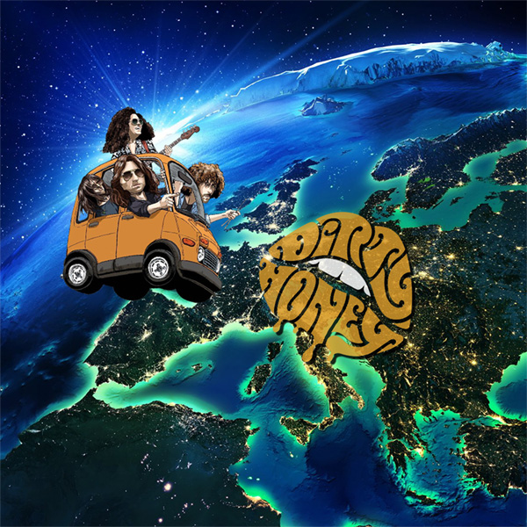

DIRTY HONEY ANNOUNCES FULL EUROPEAN TOUR
THROUGH JUNE AND JULY 2022
INCLUDING FESTIVALS AND SUPPORTS TO
GUNS N' ROSES, KISS, AND RIVAL SONS

Dirty Honey EP / LP Set for a May 20 UK/European Release
Single: "When I'm Gone" on April 22

LOS ANGELES, CA - Monday, April 4, 2022 -- Already seen as one of the most exciting new rock acts in the home country of the USA, Dirty Honey are set to establish themselves in the UK and Europe in the summer of 2022 with their debut album release and full UK and Europe touring schedule.

Their 14 track debut release, "Dirty Honey EP / LP," will be released on May 20, 2022 (Dirt Records). The band will then support this with 28 shows across twelve countries in the UK and Europe - including headline shows, festival slots, and supports to Guns N' Roses, KISS, and Rival Sons.

Vocalist Marc LaBelle says, "It's an honor to finally bring our music across the Atlantic. I've always thought we'd be well-received in the UK and Europe, and it just felt right to release both the EP and LP together after having had to wait so long to get there. It really feels like the right time to introduce Europe to our particular brand of Filthy rock n' roll, and I also can't wait to bring our live show to European audiences. Our maiden voyage across the pond is literally hitting every type of venue, from our own headlining club shows to theaters with Rival Sons and stadiums with Guns N' Roses and KISS. I can vividly remember busking in Piazza di Santa Croce in Florence, and never in my wildest dreams did I think we'd be playing some of the biggest stadiums in Europe."

While harking back to the band's influences, "Dirty Honey EP / LP" is at the same time a completely fresh, contemporary-sounding record. From the dirty groove of LP opener "California Dreamin'" to the laid-back melodic beauty of EP track "Down The Road," from the driving "Gypsy" (LP) to the riffs and infectious chorus of "Heartbreaker" (EP), this is a stunning collection of groove-laden rock songs. The band's first single from the album will be "When I'm Gone." With a performance-based video HERE, the song was the first-ever track from an unsigned band to reach the No. 1 spot on Billboard's Mainstream Rock Airplay chart.

Confirmed dates for Dirty Honey's June and July 2022 European tour are as follows:

JUNE
6 B, Malmo SWEDEN support to Rival Sons
7 Pustervik, Gothenburg SWEDEN support to Rival Sons
8 Train, Aarhus DENMARK support to Rival Sons
9 Sweden Rock Festival, Solvesborg SWEDEN
11 Download Festival, Derbyshire UK
12 The Cathouse, Glasgow UK
14 Oslo, London UK
16 Azkena Rock Festival, Vitoria-Gasteiz SPAIN
18 Rock The Ring Festival, Hinwill SWITZERLAND
19 Graspop Metal Meeting, Dessel BELGIUM
20 PGE Stadion Narodowy, Warsaw POLAND supporting Guns N’ Roses
22 Beatpol, Dresden GERMANY
24 Retro C Trop Festival, Amiens FRANCE
25 Hellfest Festival, Clisson FRANCE
27 UEA, Norwich UK support to Rival Sons
28 O2 Academy, Sheffield UK support to Rival Sons
30 Academy, Dublin IRELAND support to Rival Sons

JULY
1 Limelight, Belfast UK support to Rival Sons
2 King George’s Hall, Blackburn UK support to Rival Sons
4 University (Great Hall), Cardiff UK support to Rival Sons
5 Rock City, Nottingham UK support to Rival Sons
6 O2 Forum, Kentish Town, London UK support to Rival Sons
8 Olympiastadion, Munich GERMANY supporting Guns N’ Roses
9 Arena Zagreb, Zagreb CROATIA supporting KISS
10 San Siro, Milan ITALY supporting Guns ‘N’ Roses
12 Sequoie Music Festival, Bologna ITALY supporting Guns N’ Roses
14 Budapest Arena, Budapest HUNGARY supporting KISS
15 HDI Arena, Hannover GERMANY supporting Guns N’ Roses

For ticket info, please go to https://www.dirtyhoney.com/

For "Dirty Honey EP / LP" sales information as well as tour information, please click HERE.

EP tracklisting:
1. When I’m Gone
2. Rolling 7s
3. Heartbreaker
4. Down The Road
5. Scars
6. Break You

LP tracklisting:
1. California Dreamin’
2. The Wire
3. Tied Up
4. Take My Hand
5. Gypsy
6. No Warning
7. Another Last Time
8. The Morning

Dirty Honey, L-R: John Notto, Marc LaBelle, Corey Coverstone, Justin Smolian
Photo credit: Daniel Prakopcyk

www.dirtyhoney.com
For bio, photos, more info, go HERE

