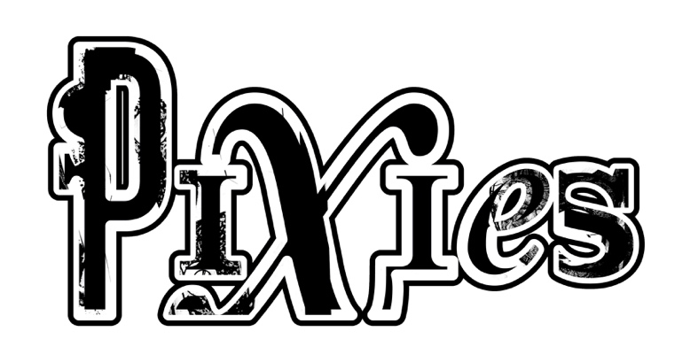

About the Pixies
While Pixies have been acclaimed as the most influential, pioneering band of the late 80s alt/rock movement, having blazed the trail for artists from Nirvana to Radiohead to Pearl Jam, today, a whole new generation of music fans is discovering the band's iconic “loudquietloud” signature sound. After five genre-defining studio albums -- including the now-Platinum-certified Doolittle — Pixies disbanded in 1993, and then launched their reunion tour in April 2004, playing to sell-out crowds across the globe for 15 years, a far longer period of time than they were a band originally. But writing, recording and releasing new music was something that the band had been wanting to do for a long time, so they secretly booked studio time in Wales for the fall of 2012. Six days into the recording, founding bassist Kim Deal decided to leave the band; Black Francis, Joey Santiago and David Lovering made the decision to carry on, finishing and releasing the band’s first studio album in more than two decades, 2014’s Indie Cindy. Also wanting to play live, the three began working with a number of touring bassists, including former A Perfect Circle bassist, Paz Lenchantin who came out on the road with the band in 2014. The band welcomed her as Pixies' permanent bassist in 2016.

Also in 2016, Pixies released its second post-reunion studio album, Head Carrier which was also Lenchantin’s recording debut with the band. As the UK’s DIY put it, “They’re back. They’re still brilliant. God save the Pixies.”

December 2018 saw the band holed up at Dreamland Studios near Woodstock, NY with producer Tom Dalgety (Ghost, Royal Blood, Pixies’ Head Carrier), where they recorded Beneath the Eyrie, their second album as a unit, due out September 13, 2019 on the band’s new label, Infectious/ BMG. Pixies decided to give fans an up-close look at the recording process, letting them witness the evolution of all the tracks, and offering their thoughts and observations over the course of recording. Hosted by New York Times writer Tony Fletcher, the 12-episode “It’s a Pixies Podcast" debuts globally on June 27 on Apple, Spotify, Acast, Stitcher, Google, and other podcast platforms.

With their much beloved album Doolittle having been certified Platinum in early 2019, Pixies plan to kick off its 2019-2020 World Tour on August 31 at the Daydream Festival in Pasadena, CA, and then head to the UK for its first European tour in two years launching September 13 and playing 33-dates across 16 European countries.

06/01/19

