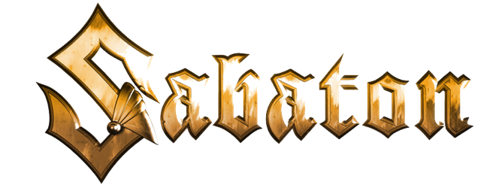
The War to End All Wars
"The Valley of Death"

Music: Joakim Brodén & Chris Rörland
Lyrics: Pär Sundström & Joakim Brodén

Dug in deep, equipped for attack
Outnumbered, determined to win
Double trench lines that won’t give in
They’re prepared let the battle begin

Here again they’ve done this before
A lesson that they should have learned by now
Reinforced with new men and guns
Who are ready for death when it comes

United they’re strong, united they’re holding the line
The Valley of Death, awaiting the British as they come their way

Their attack is coming fight them back
Bulgarians holding the line
Facing wave after wave, will never surrender
Again, again, again, again
They attack, Bulgaria held them back
Unleash their counter barrage
Let it rain artillery pounding the trenches
No surrender, fight them until the end

Fortified, and made to defy
Protected by wires and guns
Troops as far as the eye can see
They advance under Vazovs command

Row on row, as they come from below
Twice they attack, twice they’re beaten back
Every time they try, they will die
Their line of defence is still intact

For white, green and red, for the nation they’re fighting for
The British are done, three times the defence of Doiran has been won

