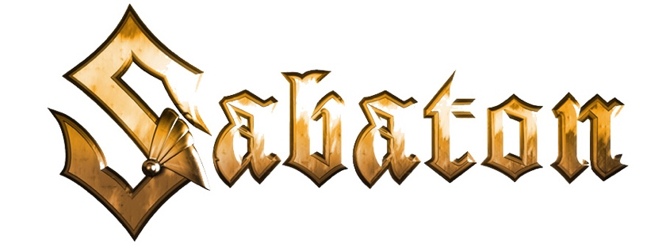

The War To End All Wars • Album Credits

Produced by Sabaton

Recorded at: Black Lounge Studio, Grängarde, Sweden

Recorded and Engineered by: Jonas Kjellgren

Mixed and Mastered by: Jonas Kjellgren at Black Lounge Studio

Sabaton is:
Joakim Brodén • Vocals
Pär Sundström • Bass
Chris Rörland • Guitar
Tommy Johansson • Guitar
Hannes Van Dahl • Drums

Female backing vocals:
Mia Mullback, Åsa Österlund, Hannele Junkala, Sofia Lundberg

Male backing vocals:
Christer Gärds, Anders Sandström, Pelle Hindén, Joakim Brodén, Chris Rörland, Tommy Johansson,
Jonas Kjellgren

Additional vocals on "The Christmas Truce":
Gospel Choir - Flowing Chords

Narration:
Bethan Dixon Bate

Publishing:
All songs published by Stuffed Beaver, Ltd.
and administrated by Warner Chappell Music Scandinavia (STIM)
and ASCAP in the United States

