FOR IMMEDIATE RELEASE

WITH THEIR DEBUT SINGLE “CHOKE” ALREADY
STAKING A CLAIM IN THE TOP 30 AT ALTERNATIVE RADIO
1 DONT KNOW HOW BUT THEY FOUND ME
ANNOUNCES “NIGHT HEAT,”
THE BAND’S SPRING NORTH AMERICAN CONCERT TOUR
“iDKHOW are poised to save the world from musical boredom, one riff at a time.”
-- Alternative Press
“Discovering iDKHOW is like striking gold in an unexpected place.” - idobi Radio

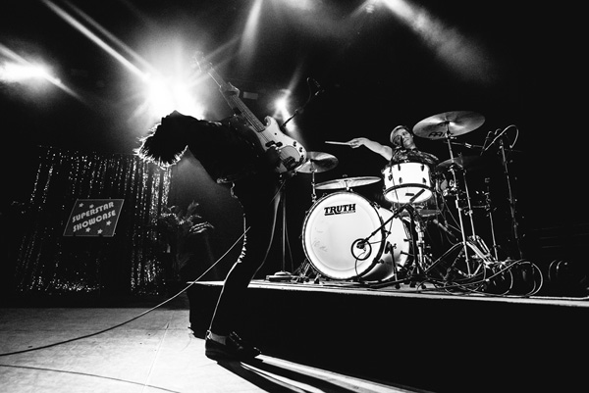

LOS ANGELES, CA - (Wednesday, March 20, 2019) - Today, I DONT KNOW HOW BUT THEY FOUND ME, aka iDKHOW - comprised of long-time Panic! At The Disco bassist Dallon Weekes and one of the songwriters/ lyricists behind Panic's Gold release Too Weird to Live, Too Rare to Die!, and drummer Ryan Seaman - announce dates for the band's 2019 Spring North American tour, dubbed "Night Heat." The band will bring its catchy, alternative music along with Weekes' theatrical persona and disarming crowd involvement to 17 stops on the tour, headlining
clubs as well as performing at two major outdoor festivals. The tour kicks off on Sunday, April 28 at ALT 93.3 radio station's "Band Splash" festival in Phoenix, AZ. For all headline dates, the Los Angeles rock band Superet will provide support. The artist presale for the headline dates takes place tomorrow, Thursday, March 21 from 10AM (local) to 10PM (local); tickets go on sale to the general public this Friday, March 22 at 10AM (local); for all ticket presale and purchasing details, log on to www.idkhow.com The complete itinerary is below.

iDKHOW's tour is in support of the band's debut EP 1981 Extended Play (Fearless) that was released late last year, and the EP's first single "Choke." The EP, already with nearly 26-million streams, debuted at #1 on
Billboard's Heatseekers Chart, and "Choke," a musically upbeat, lyrically acerbic song about some of the more toxic aspects of Los Angeles culture and the entertainment industry, has sailed into the Top 30 at Alternative radio after just three weeks. The track and its companion videos have racked up more than 26-million hits to date and the single has been added to the playlists of some 48 alternative radio stations including Los Angeles, New York, Philadelphia, San Francisco, Chicago, San Diego, Houston, Miami, St. Louis and Phoenix. Recently having graced the covers of Alternative Press and the UK's Rock Sound magazines, iDKHOW was named the "2019 Artist to Watch" by Amazon and "Artist on the Rise" by YouTube.

Dates for "Night Heat," iDKHOW's Spring 2019 North American tour are as follows:

APRIL
28 Big Surf Water Park, Phoenix, AZ (ALT 93.3 radio fest)
29 House of Blues, Bronze Peacock, Houston, TX (HL)
30 House of Blues, Cambridge Room, Dallas, TX (HL)

MAY
2. The Abbey, Orlando, FL (HL)
3 Shaky Knees, Atlanta, GA
4 Cat's Cradle, Carrboro, NC (HL)
6 Union Stage, Washington, D.C. (HL)
7 Rex Theatre, Pittsburgh, PA (HL)
8 Opera House/Canadian Music Week, Toronto, ON (HL)
10 Montage Music Hall, Rochester, NY (HL)
11 Webster Theatre, Hartford, CT (HL)
12 Bowery Ballroom, New York, NY (HL)
13 Union Transfer, Philadelphia, PA (HL)
15 Lincoln Hall, Chicago, IL (HL)
16 Delmar Hall, St. Louis, MO (HL)
17 The Majestic, Madison, WI (HL)
18 Fine Line Cafe, Minneapolis, MN (HL)

*****

ABOUT I DONT KNOW HOW BUT THEY FOUND ME (iDKHOW)
I DONT KNOW HOW BUT THEY FOUND ME - Dallon Weekes and Ryan Seaman - is a musical entity with a conceptual backstory. The name, a key to their remarkable odyssey, is taken from a piece of dialogue from the 80s classic film "Back To The Future." They are a lost act from the late 70s early 80s that never quite made it, but their rare and long-forgotten music has recently been unearthed thanks to today's technological resources. Weekes and Seaman are just starting to resurrect the songs and innovative spirit of iDKHOW for a new generation starved for creative risk-taking and unbound joy.

I DONT KNOW HOW BUT THEY FOUND ME is getting a second chance. For the first time.

# # #

