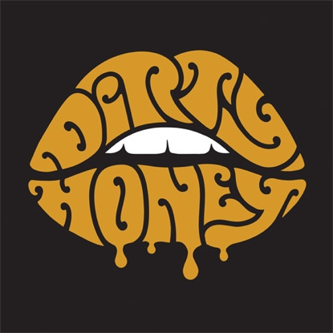

ABOUT DIRTY HONEY
To say that 2019 was a breakout year for Dirty Honey would be an understatement. Recorded in Byron Bay, Australia with producer Nick DiDia (Pearl Jam, Rage Against The Machine), the band released its self-titled debut EP in March 2019. Over the course of the last year-plus, Dirty Honey opened for The Who, Guns N’ Roses, and Slash ft. Myles Kennedy & The Conspirators, performed at more than a dozen major summer festivals including Welcome to Rockville, Louder Than Life, Heavy MTL, Rocklahoma, Sonic Temple and Epicenter, and played to SRO crowds at every show on its first-ever headline tour in December and January & February this year. Dirty Honey also made music history when it became the only unsigned artist ever to hit #1 on Billboard’s Mainstream Rock Chart with its debut track “When I’m Gone.” Additionally, the band was named Canadian Rock Radio’s #1 International Breakout Artist of 2019, Loudwire cited “When I’m Gone” as one of the “66 Best Songs of the Decade,” the UK’s Louder/Classic Rock magazine hailed Dirty Honey as one of the “20 great bands to shake up the 2020s," and the band was nominated as Best New Rock/Alternative Artist for the 2020 iHeartRadio Music Awards. “Rolling 7s,” Dirty Honey's second single, went all the way to #4 at Rock Radio, and the band has racked up more than 28.6-million total streams.

Dirty Honey is both a destination and a beginning for the band. Mostly, however, it's the first of what Dirty Honey hopes will be many declarations of rock 'n' roll prowess and creative intent, forging a fresh path from familiar conventions.

# # #

6/1/20

