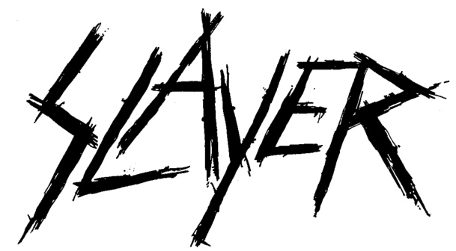

FOR IMMEDIATE RELEASE

SLAYER ANNOUNCES “THE REPENTLESS KILLOGY” MOTION PICTURE AND “THE REPENTLESS KILLOGY,
LIVE AT THE FORUM IN INGLEWOOD, CA” LP/CD

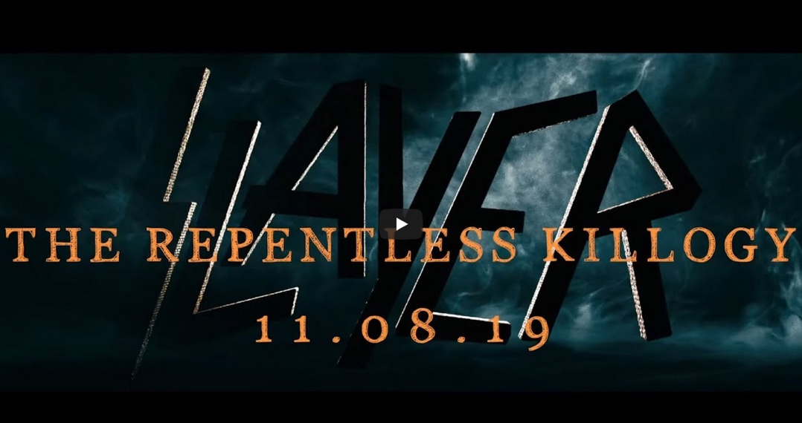

LOS ANGELES, CA - Friday, September 13, 2019 — After much speculation instigated by two video trailers released earlier this summer, Slayer - Tom Araya, Kerry King, Gary Holt and Paul Bostaph - in conjunction with Nuclear Blast Records and Prime Zero Productions, announces “Slayer: The Repentless Killogy” motion picture and companion LP/CD, “The Repentless Killogy, Live At The Forum in Inglewood, CA.” Coming November 8, 2019, the narrative short film paired with Slayer’s entire performance of its August 5, 2017 concert at the Los Angeles Forum will be available digitally and on Blu-ray, and the soundtrack from that concert will be released as both a two-disc vinyl and two CD packages. In addition to the standard black vinyl, eight limited-edition colored vinyl configurations will be available: red, gold and silver vinyl, red/black & orange splatter, red/orange swirl, red/black splatter, yellow/red corona, and black/white corona Pre-orders can be placed HERE. Check out the trailer for this special movie release HERE.

Revenge, murder, bloodshed and retribution. The “Repentless Killogy” film was written and directed by BJ McDonnell, who conceived and directed the three brutal music videos - “You Against You,” “Repentless,” and “Pride in Prejudice”- for Slayer’s final studio album Repentless (2015).

“When we set out to do these initial three videos,” said McDonnell, "we had the intention of continuing the next adventures of Slayer and Wyatt on a following album. But, Slayer announced that ‘Repentless' was the final album and tour, so this story, the videos, and finally a full live concert at the end is a perfect wrap up of the ‘Repentless’ final tour. This is the finale of Slayer. This is the end of the monsters."

The “Repentless Trilogy” motion picture opens with the three music videos assembled as one chronological storyline and introduces the narrative’s main character, Wyatt, a former Neo Nazi associated with a gang known as “The Hand Brotherhood,” whose signature mark was a bloody handprint left after a murder had taken place. Prior to the first music video, Wyatt had left the gang after he fell in love with Gina. The two had gone into hiding to escape his grisly past and start a family, but The Hand Brotherhood was not going to allow that to happen, and Gina, pregnant with their first child, was savagely murdered as Wyatt was forced to look on. The film then segues into the present-time narrative that sees Wyatt on the run from law enforcement and the Nazi gang, but now dedicated to eliminating The Hand Brotherhood and seeking retribution wherever he can.

“The Repentless Killogy” stars many of the actors who appeared in the original video series: Jason Trost (“Beats of Rage,” “Hatchet III”) as Wyatt, Danny Trejo (“Machete,” “From Dusk Til Dawn”), Richard Speight (“Band of Brothers,” “Supernatural”), Derek Mears (“Agents of S.H.I.E.L.D.”), Jessica Pimentel (“Orange Is The New Black”), Tyler Mane (“X-Men,” “Halloween !!”), Bill Moseley (“The Devil’s Rejects,” “The Texas Chainsaw Massacre 2”), Caroline Williams (“The Texas Chainsaw Massacre 2,” “Sharknado 4”), and Sean Whalen (“Twister,” “The People Under The Stairs”).

Part two of “The Repentless Killogy” features Slayer’s entire live set performed at the Los Angeles Forum on August 5, 2017, and was directed by Wayne Isham who has directed videos for artists including Metallica, Foo Fighters, Michael Jackson, Kelly Clarkson, and Britney Spears. Presented in front of one of the most striking stage productions of the band’s career, Slayer performs fan-favorites including “South of Heaven,” “War Ensemble,” “Mandatory Suicide,” “Dead Skin Mask,” “Raining Blood,” and “Angel of Death.”

Slayer will begin The Final Campaign, the last leg of its Final World Tour on November 2, wrapping its touring career up with two shows at The Forum in Los Angeles on November 29 and 30. Those final dates are below.

OCTOBER
4 Rock In Rio, Rio de Janeiro, Brazil
11 Exit 111 Festival, Great Stage Park, Manchester, TN

NOVEMBER
2 Explore Asheville Arena, Asheville, NC
3 PNC Arena, Raleigh, NC
5 Salem Civic Center, Salem, VA
6 Giant Center, Hershey, PA
8 Mass Mutual Center, Springfield, MA
9 Madison Square Garden, New York, NY
11 KFC Yum! Center, Louisville, KY
12 Nationwide Arena, Columbus, OH
14 TaxSlayer Arena, Moline, IL
15 Denny Sanford Premier Center, Sioux Falls, SD
17 Fargodome, Fargo, ND
18 CHI Health Center, Omaha, NE
20 Broadmore World Arena, Colorado Springs, CO
22 First Interstate Arena at MetraPark, Billings, MT
24 Spokane Arena, Spokane, WA
26 Oracle Arena, Oakland, CA
27 Grand Garden Arena, Las Vegas, NV
30 The Forum, Los Angeles, CA

ABOUT SLAYER - www.slayer.net:
For nearly four decades, Slayer's onslaught has proven them to be the supreme thrash-metal band on the planet, the band that other heavy acts are measured against and aspire to. Their membership in "The Big Four" - Metallica, Slayer, Megadeth and Anthrax - the four bands that defined the thrash/metal genre - secures the band's place in music history.
The five-time nominated, two-time GRAMMY-winners have accumulated an abundance of certified Gold albums along with "Best..." awards from media outlets all over the world, including Kerrang!, SPIN, Metal Hammer, Revolver, and Esquire. Throughout Slayer's history, the band has never faltered in unleashing its extreme and focused sonic assault, and, unlike many of its contemporaries who commercialized their sound, Slayer has remained crushing and brutal, steadfastly refusing to cater to the mainstream. Slayer's founding member, guitarist Jeff Hanneman passed in 2013, and Exodus guitarist Gary Holt has been filling in for him since. Paul Bostaph, who was Slayer's drummer from '94 - '01, rejoined bassist/vocalist Tom Araya and guitarist Kerry King in 2013, and is back behind the kit to the end.
In January 2018, Slayer announced they were calling it a day and would be doing one final world tour to thank its fans for their support over the years. Launched on May 10, 2018, by the time the 18-month tour wraps, Slayer will have said goodbye to fans in 30 countries around the world and in 40 U.S. states by the time the last date is played on Saturday, November 30 in the band’s hometown of Southern California.

# # #

