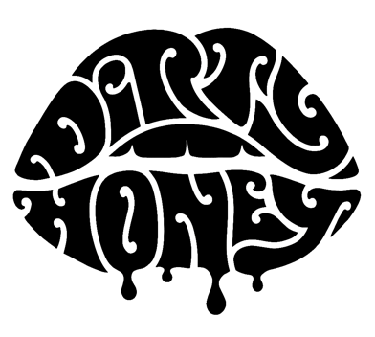

About Dirty Honey (2021)

To say that 2019 was a breakout year for Dirty Honey would be an understatement. Recorded in Byron Bay, Australia with producer Nick DiDia (Pearl Jam, Rage Against The Machine), the band released its self-titled debut EP in March 2019. Dirty Honey didn’t waste any time before making music history when it became the only unsigned artist ever to hit #1 on Billboard's Hard Rock and Mainstream Rock Chart with its debut track "When I'm Gone.” The band's second single/video, “Rollin 7s," went to #3 at Rock Radio (and was still headed up when COVID changed everything), and its music video has racked up just shy of 7-million YouTube plays. Between the Fall of 2018 and early 2020, Dirty Honey opened for The Who, Guns N' Roses, and Slash ft. Myles Kennedy & The Conspirators, performed at more than a dozen major summer festivals, including Welcome to Rockville, Louder Than Life, Heavy MTL, Rocklahoma, Sonic Temple and Epicenter, and played to sold-out crowds at every show on its first-ever U.S. headline tour in December, January and February 2020. Additionally, Dirty Honey was named Canadian Rock Radio's #1 International Breakout Artist of 2019, the band was nominated as Best New Rock/Alternative Artist for the 2020 iHeartRadio Music Awards, and Rolling Stone wrote about the band as an “Artist You Need To Know.”

March 5, 2021 saw the release of the band's new single and music video "California Dreamin'" followed on April 23 by Dirty Honey's self-titled, debut album that debuted at #2 on the Current Hard Rock Albums Chart. Over the summer of 2021, Dirty Honey was main support on The Black Crowes "Shake Your Money Maker" amphitheater tour where the band received glowing reviews as well as standing ovations at the majority of the tour's 35 shows.

Dirty Honey and Mammoth WVH kick off their 30-date, North American co-headline "Young Guns" tour, on January 21, 2022

# # #

