FOR IMMEDIATE RELEASE

METAL ON METAL: DARK HORSE COMICS’
“SLAYER: REPENTLESS” #1 TO HIT JANUARY 2017

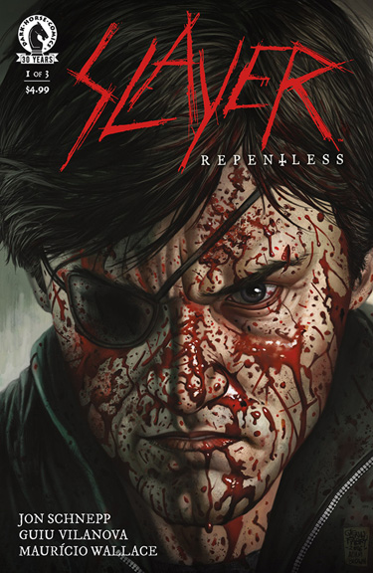

LOS ANGELES, CA., (November 21, 2016)-Legendary heavy metal band Slayer has teamed up with Metalocalypse writer Jon Schnepp and Twilight Zone artist Guiu Vilanova for a three-issue Dark Horse Comics series,Slayer: Repentless, with covers by Eisner Award-winning British comics artist Glenn Fabry. The first issue, with a variant cover by Eric Powell (The Goon,Hillbilly), is scheduled for release on January 25, 2017.

Slayer: Repentless #1 (of 3) is available for preorder on the Dark Horse website.

"It's been my honor to chronicle the bloody road trip that is the Slayer comic series from Dark Horse/Nuclear Blast," said writer Jon Schnepp. "Using the band's music and lyrics from their three decades of albums, while crossing over and through the Repentless music videos by BJ McDonnell, I have woven a tale of betrayal, hate, perspective, loyalty, family, and murder that will need to be experienced through the comic books' pages."

With its story of a raging road trip down a bloodstained highway, a tale of the doomed and the damned, the Slayer: Repentless series is an expansion of Slayer's Repentless videos, written and directed by BJ McDonnell (Hatchet III).

The band made an appearance at San Diego Comic-Con 2016, with a subsequent sold-out performance at the House of Blues, in support of the Dark Horse Comics series.

ABOUT SLAYER:
For more than three decades, Slayer's onslaught has proven the band to be the supreme thrash-metal band on the planet, the band that other heavy acts are measured against and aspire to. Their membership in "The Big Four" - Metallica, Slayer, Megadeth and Anthrax - the four bands that defined the thrash/metal genre - secures their place in music history. The two-time Grammy-winners have also accumulated an abundance of certified Gold Albums along with "Best..." awards from media outlets all over the world, including Kerrang!, SPIN, Metal Hammer, Revolver, and Esquire. Throughout Slayer's history, the band has never faltered in unleashing its extreme and focused sonic assault, and, unlike many of its contemporaries who "commercialized" their sound, Slayer has remained crushing and brutal, steadfastly refusing to cater to the mainstream. Slayer's founding member, guitarist Jeff Hanneman passed in 2013, and Exodus guitarist Gary Holt has been filling in for him since. Paul Bostaph, who was Slayer's drummer from '94 - '01, has rejoined bassist/vocalist Tom Araya and guitarist Kerry King, and is back behind the kit.

In September 2015, Slayer released Repentless, the band's 12th studio album, the first without Hanneman and first with producer Terry Date, to widespread rave reviews and the highest chart debut of the band's career. The band also teamed up with director BJ McDonnell for three high-concept and brutal music videos for the album's "Repentless", then for "You Against You," and the most recent, "Pride in Prejudice." Dark Horse Comics will publish a three-issue comic book series this fall based on McDonnell's original story concept for the videos and written by Jon Schnepp.

ABOUT DARK HORSE:
For thirty years, Dark Horse Comics has proven to be a solid example of how integrity and innovation can help broaden a unique storytelling medium and establish a small, homegrown company as an industry giant. Founded in 1986 by Mike Richardson, the company is known for the progressive and creator-friendly atmosphere it provides for writers and artists. In addition to publishing comics from top talent, such as Eric Powell, Mike Mignola, Geof Darrow, Brian Wood, Gail Simone, Stan Sakai, and Guillermo del Toro, and comics legends, such as Will Eisner, Milo Manara, Kazuo Koike, Neil Gaiman, and Frank Miller, Dark Horse has developed its own successful properties, such as The Mask, Ghost, X, and Barb Wire. Its successful line of comics, manga, and products based on popular properties includes Dragon Age, Buffy the Vampire Slayer, Aliens, Conan, Tomb Raider, Halo, The Witcher, Serenity, Game of Thrones, and Avatar: The Last Airbender. Today Dark Horse Comics is the largest independent comic book publisher in the US and is recognized as one of the world's leading entertainment publishers.

# # #

