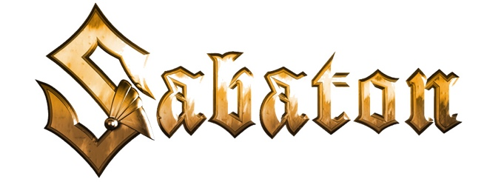
"Steel Commanders" Lyrics

Verse 1

Over 100 years ago since we first rode into fire
The rulers of the battlefield, rolling over trench and wire

Into battle, no retreat, roll out, for our foes we spell disaster
In the footsteps of Montgomery, Patton followed we came after

Pre-chorus

Flers-Courcelette showed the way
Evolution leading to
El - Alamein until today
We’re the first ones into the fray

Chorus

Steel commanders
Rule the battlefield
Spearhead Flanders
Tankers leading the
Storm of panzers
Battle calling the
Steel commanders

Verse 2

From the Mark 1´s introduction to the beast known as the Leopard
With our Chieftains and Centurions our frontline has been tempered

From the fields of Prokhorovka, to the shores of Overlord
The beginning of the victory, Shermans rolling on to Sword

