FOR IMMEDIATE RELEASE

WITH A LITTLE HELP FROM HIS FRIENDS, ANTHRAX’S CHARLIE BENANTE ANNOUNCES NEW ALBUM, SILVER LININGS
The Album’s "Run-DMC Medley," Featuring Darryl “DMC” McDaniels, Rob Caggiano (Volbeat),

Ra Diaz (Suicidal Tendencies) and Benant
is Released Today and Can Be Streamed HERE

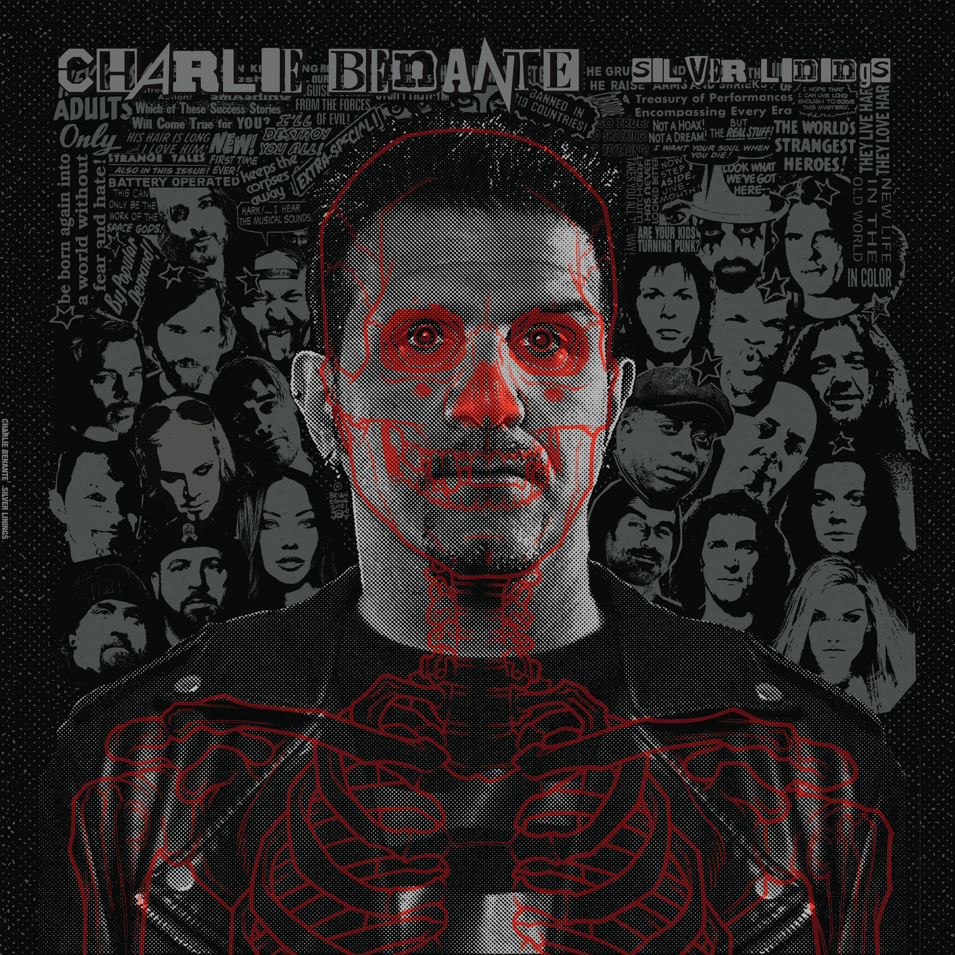
LOS ANGELES, CA - Friday, March 19, 2021 — Today, Anthrax’s Charlie Benante announces a brand new album, 14-tracks that feature an all-star cast of “who’s who” in the thrash, metal, and rock worlds. With all cuts culled from Benante’s acclaimed 'quarantine jam video series,’ the album is aptly titled Silver Linings and is due out May 14 (Megaforce Records). Benante has earmarked a portion of the Silver Linings proceeds for the , an organization that provides musical instruments and lessons to students and makes donations to much-needed mental health organizations that sup- port musicians in need. Today, the album’s track “Run-DMC Medley,” featuring Darryl “ DMC” McDaniels, Volbeat’s Rob Caggiano, Ra Diaz from Suicidal Tenden- cies, and Benante, is released; the song can be streamed the song HERE, and the video of the original 'quarantine jam” session can be viewed HERE. Silver Linings digital and vinyl pre-orders can be placed HERE.

“Back in February of last year,“ Benante remembers, "with COVID and all the other B.S. that was going on, I was glued to the 24-hour news cycle on the TV and my phone, and I started to get really depressed. My girlfriend said I needed to turn off the news and suggested I do something creative, whether it was art or drumming or writing new songs, and she was right."

Benante set up his electric drum kit at home in his art room and started playing along with music he had grown up listening to. It pulled him out of his depression and reignited his creative drive. "I knew a lot of my musician friends were going through the same thing I had been, so I started asking them if they wanted to get involved, play some songs with me, maybe make a video
— that’s how it all started.”

Throughout the ‘quarantine video series,' Benante collaborated on jams with fellow Anthrax bandmates Frank Bello, Scott Ian and Jon Donais, his girlfriend, Carla Harvey (Butcher Babies), Corey Taylor (Slipknot), Ra Diaz (Suicidal Tendencies), Mark Osegueda (Death Angel), John 5 (Rob Zombie), and Alex Skolnick (Testament), among many more. Some of Charlie’s favorite songs by Rush, Tom Petty, The Beastie Boys, Stormtroopers of Death, Kings X, Run DMC, Massive Attack, U2, Fugazi, The Chemical Brothers, and Billie Eilish were covered.

For the album’s cover art, Charlie recruited his friend, artist Brian Ewing, whose art he’s always loved. “I think he did a great job,” said Charlie, “and the package's artwork ties in my fascination with horror."

“This isn’t a solo album,” Charlie added, "this is a record of my favorite songs done with some of my friends during a very dark time. We found a shining light and this is the result of that light. I was really happy that my musician friends came on board and helped make this record what it is. I appreciate all of them, and they all did such a fantastic job. Despite all of the darkness we’ve experienced this past year, there are ’silver linings,' that’s why I chose that title for the album.”

The tracklisting for Charlie Benante’s Silver Lining is as follows:

“City of Blinding Lights”/U2 - Frank Bello, Mark Osegueda, Charlie Benante
“Chloe Dancer / Crown of Horns”/Mother Love Bone - Mark Menghi, Mark Osegueda, Charlie Benante “Teardrop”/Massive Attack - Carla Harvey, Ra Diaz, Charlie Benante
“Run DMC”/Run DMC - DMC, Rob Caggiano, Ra Diaz, Charlie Benante “Rhiannon”/Fleetwood Mac - Mark Menghi, Jennifer Cella, Randy McStine, Charlie Benante “Yer So Bad”/Tom Petty - Carla Harvey, Ra Diaz, Charlie Benante
“Transylvania”/Iron Maiden - Snake Sabo, Frank Bello, Jon Donias, Charlie Benante “Presto Vivace”/U.K. - Ra Diaz, Alex Skolnick, Jordan Rudess, Charlie Benante “Bad Guy”/Billie Eilish - Ra Diaz, Charlie Benante
“Jimmy James”/The Beastie Boys - Ra Diaz, Charlie Benante
“All The Way”/KISS - PJ Farley, Joe McGinness, John 5, Charlie Benante “Mr Speed”/KISS - Joe McGinness, PJ Farley, Charlie Benante
“Public Image”/Public Image - Hank Von Hell, Dave Brownsound, Jason “Cone” McCaslin, Charlie Benante “Funny Vibe”/Living Color - Ra Diaz, Corey Glover, Henry Flury, Charlie Benante

# # #
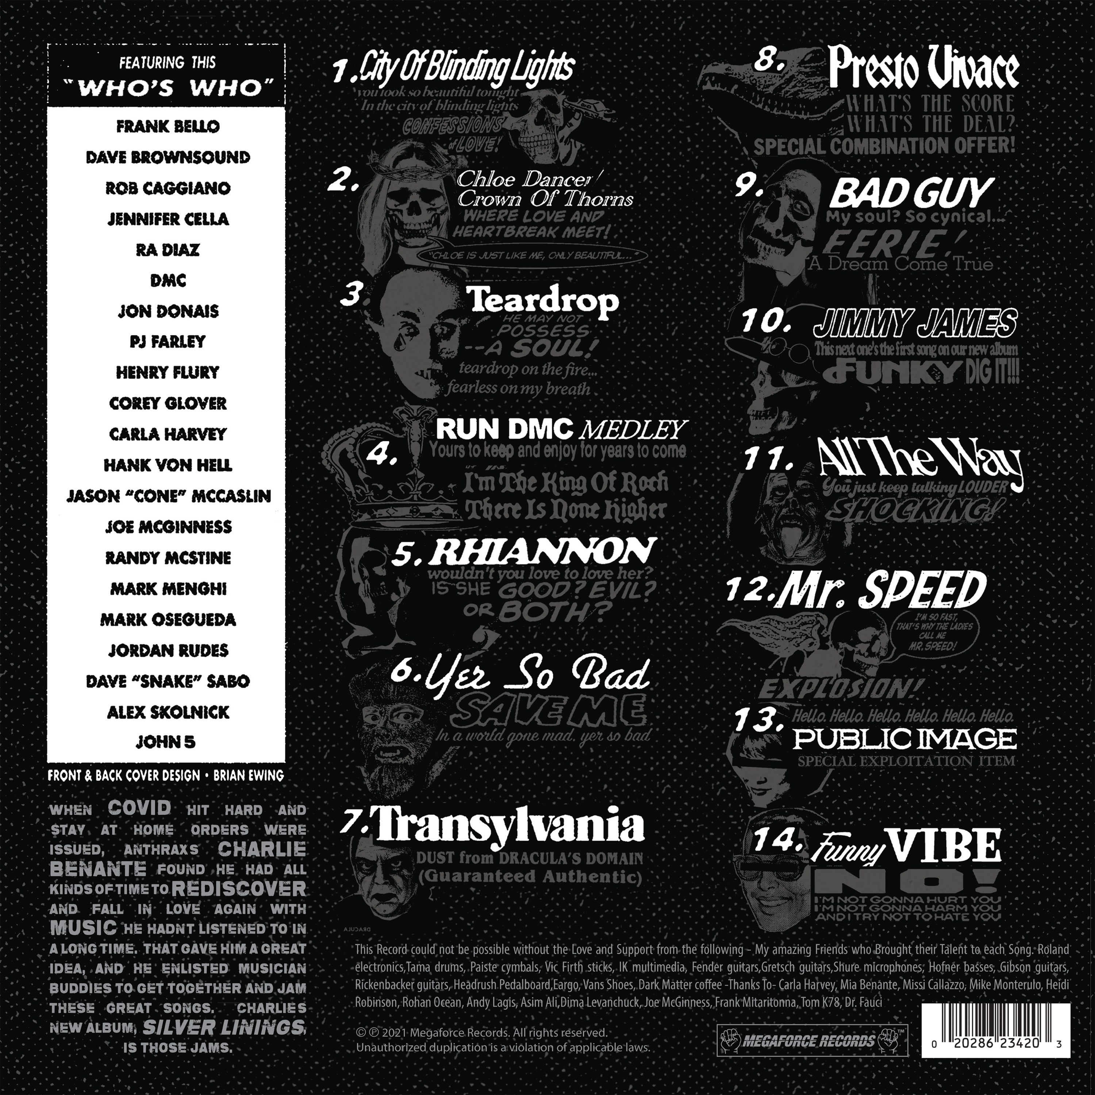
Media Contact:
Heidi Ellen Robinson-Fitzgerald • herfitz@mac.com • 818-705-1267

