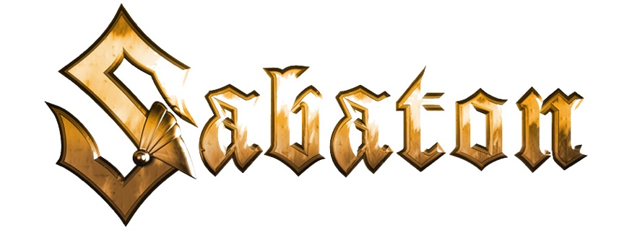

About Sabaton
​
Joakim Brodén/Vocals, Pär Sundström/Bass, Chris Rörland/Guitar,
Tommy Johansson/Guitar, and Hannes Van Dahl/Drums
​
In the more than two decades since their launch, Swedish metallers Sabaton have achieved quadruple-Platinum sales, headlined major festivals and sold-out arena concerts across the globe, and earned a legion of loyal fans by carving out a reputation as one of the hardest working bands in rock. Sabaton combines standout stage design and production with epic concept albums, linking real-life historical war events with classic kick-ass metal. To date, the band has released ten studio albums, amassed six GOLD, two PLATINUM, and one four-times-PLATINUM awards, seen eight of its albums score Top 10 international chart status, and six claim the Top 5. The band has earned eight Metal Hammer/Golden Gods Awards nominations, taking home the award for "Breakthrough Artist" in 2011 and "Best Live Band" in three different years, and a Grammis nomination (Swedish equivalent to the U.S. GRAMMY) as Best Heavy Metal band. Sabaton has also accumulated more than two billion streams across all streaming platforms.

Beyond Platinum albums and sold-out arena tours, Sabaton hosts its annual, three-day concert festival, "Sabaton Open Air," held at the Lugnet ski stadium in Sweden, as well as the annual, always sold out, Sabaton Cruise that sails out of Stockholm for epic sea adventures, rocking the ship with fellow metalheads, and lots of SABATON. Sabaton has also launched "Sabaton History Channel," that combines the power of YouTube, music, and storytelling to dive into the true-life stories behind every Sabaton song, bringing history to life in an informative and entertaining way. Sabaton's Pär Sundstöm and Joakim Brodén are joined by the renowned historian Indy Neidell, of "The Great War" and "WW Two in Real Time" fame.

On March 4, 2022, Sabaton's tenth studio album, The War to End All Wars, was released (Nuclear Blast). Written and recorded in 2021 during the COVID global pandemic, the band has crafted a concept album of 11 brand new songs that dive deep into previously unexplored atrocities, miracles and events tied to the early 20th century's World War I.
​
Combining soaring power riffs with vocalist Brodén's instantly-recognizable gruff baritone, the band refuses to be simply slotted into a genre. Fans need only know them as Sabaton, the heavy metal band that sings of real-life wars and the people who played a part in them; of grueling campaigns and dazzling acts of bravery, magnificent victories, and touching personal struggles, true stories more fantastic than any fiction.

3/2022

