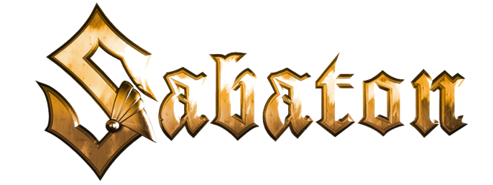

The War to End All Wars
"The Unkillable Soldier"

Music: Joakim Brodén
Lyrics: Pär Sundström & Joakim Brodén

Into the fire through trenches and mud
Son of Belgium and Ireland with war in his blood
Leading the charge into hostile barrage
By design, he was made for the frontline

Studied law, with a thirst for war
Fought in Africa, wanted more
Back in Europe then straight to France
He’s joining the allied advance

Through the Somme and the Devil’s Wood
All the battles that he withstood
Born a soldier enjoyed the war
He always kept coming for more

Never die, shot through the eye
Never surrender however they try
How they try, shot through the eye
He’ll never die

At the edge of madness, in a time of sadness
An immortal soldier, finds his home
Proven under fire, over trench and wire
No fear of death he’s unshakeable

In the battles, when he was shot
Kept on fighting, and never stopped
In Arras, Cambrai, Passchendaele
Ignoring his wounds he prevailed

Save the day, he’ll never stray
Facing the foes that are coming his way
Come his way, he’ll never stray
Saving the day

At the edge of madness, in a time of sadness
An immortal soldier, finds his home
Proven under fire, over trench and wire
Forged for the war he’s unbreakable
At the edge of madness, he will show no sadness
Never broken, he’ll be back for more
Proven under fire, over trench and wire
No fear of death he’s unshakeable

Edge of madness!
No fear of death, he is forged for the war, he will always be coming for more

