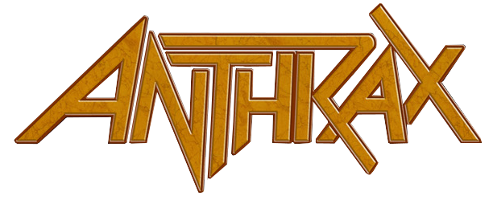

LEGENDARY THRASH METAL BAND ANTHRAX
ANNOUNCES 40TH ANNIVERSARY CELEBRATIONS

Friends, Music Elite & Former Members To Contribute Series Of
Video Testimonials Starting May 3
Leading Up To Official July 18 Anniversary
Celebration To Culminate With A Special Anthrax Livestream Event
Offering A Set List That Will Span The Band’s Career
Check out the Anniversary Trailer HERE

New York, NY - (Thursday, April 29, 2021) -- One of The Big Four turns the Big 4-0 this year and is celebrating with a number of special activities and events to honor the landmark anniversary. Formed by guitarist Scott Ian and bassist Dan Lilker in Queens, NY on July 18, 1981, Anthrax was one of the first thrash metal bands to emerge from the East Coast and quickly became regarded as a leader in the genre alongside Metallica, Slayer, and Megadeth.

Active over the past five decades, Anthrax has released 11 studio albums, been awarded multiple Gold and Platinum certifications, received six Grammy nominations, toured the world since 1984 playing thousands of shows, including headlining Madison Square Garden and playing Yankee Stadium with The Big 4. The band has built a strong reputation with fans as well as the record industry. With the lineup including Ian, bassist Frank Bello, drummer Charlie Benante, singer Joey Belladonna, and guitarist Jon Donais, the band is being feted on their 40th anniversary by a wide range of friends and music contemporaries.

Each week beginning May 3, on Mondays, Wednesdays, and Fridays, and wrapping on the band’s official founding anniversary of July 18, Anthrax’s social media accounts will offer “Anthrax 40 for 40," a series of video testimonials that features former band members, fellow musicians, colleagues, and industry veterans sharing behind-the-scenes stories of working with the band, and what Anthrax’s legacy has meant all these years on. These videos will honor each album in chronological order beginning with the original release, Fistful of Metal. Go HERE for the full schedule.

The 11-week series will include video contributions from Chuck D, Corey Taylor, Dave Grohl, Dave Mustaine, Gary Holt, Gene Simmons, Henry Rollins, John Carpenter, Kerry King, Mike Patton, Nergal, Norman Reedus, Michael Poulsen, Rob Zombie, Robert Trujillo, Roger Miret, Darryl McDaniels (Run DMC), Slash, Tom Morello and more. There will also be video clips from former Anthrax band members Dan Lilker, Dan Spitz, John Bush, Neil Turbin, and Rob Caggiano.

The finale will come as a very special Livestream performance from Anthrax on Friday, July 16, featuring a deep cuts set that will pull from the band’s entire career-spanning catalog. All details including ticketing information will be announced shortly.

Fans will also be able to get their hands on a special 40th anniversary-edition bottle of Anthrax bourbon to enjoy during the Livestream and keep as a commemorative keepsake. More details will be coming soon.

* * *

ABOUT ANTHRAX: Twenty-twenty-one marks Anthrax's 40th anniversary, during which time the band has released 11 studio albums, been awarded multiple Gold and Platinum certifications, six Grammy nominations, and a host of other accolades from the media, the music industry, and fans. In 1991, the band helped break down race and genre barriers when they collaborated with Public Enemy on the track "Bring The Noise," and was the first metal band to have its music heard on Mars when NASA played "Got The Time" to wake up the Mars Rover in 2012. Along with Metallica, Slayer, and Megadeth, Anthrax is a card-carrying member of The Big Four, the four bands that defined the speed/thrash/metal genre. Anthrax has also introduced a series now sold-out signature whiskeys and bourbons and partnered with the Stockholm-based NEZUMI Studios for a high-end, limited-edition Baleine dive watch. Twenty-twenty-one will see the release of Z2 Comics' "Among the Living" graphic novel with a track-by-track storyline inspired by Anthrax's iconic 1987 album, Among The Living. The book pulls together a "who's who" of names from the worlds of comics and music who created "bubble dialogue" and original artwork to express what the songs meant to them. Taking advantage of COVID-19's prohibition of concert touring, the band has been hard at work writing the next Anthrax album.
www.Anthrax.com
https://www.facebook.com/anthrax

