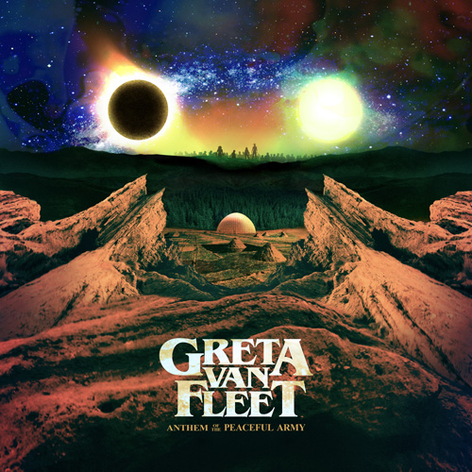

Introduction to the
Anthem of the Peaceful Army

Music, a dialect that enables us to communicate with no cultural or linguistic boundaries, that enriches and binds a human community emotionally and spiritually. It is a tool of peace and a revolution of the soul where freedom and harmony preside.

The world is a place of beauty… full of color, full of luster, diversity and synergy, where we can freely agree to disagree without acrimony. There is no darkness without light, each sunrise brings a new day; we grow, we learn, and we love. Then it is our turn to share our tales of wisdom, of love and loss, light and darkness, life and death, before we ourselves move on from this life.

We are searchers of truth as were our greatest ancestors. We are drifters, we wander lands of snow and sand in an age-old quest for answers that lie beyond this material plane. And in our search, we can encounter alluring deceptions that we mistakenly embrace as truths…sorcery.

Today… a time where innocence still survives, wonder abounds and hope resides. Before us, an assembly of love, peace, and unity, a journey for wisdom, a renaissance. We are on the precipice of adventure… a fresh chapter… a new age…

This is a call to arms… let us sing the Anthems of the Peaceful Army.

*****

ABOUT GRETA VAN FLEET
Greta Van Fleet is four young musicians - twin brothers Josh (vocals) and Jake Kiszka (guitar), both 22, younger brother Sam (bass/keys, 19), and longtime family friend Danny Wagner (drums, 19). All are from the tiny Michigan hamlet of Frankenmuth known for its family-style chicken dinners and the world’s largest Christmas store. All four were raised on their parents’ extensive vinyl collections which helped give birth to the music they make today: a high-energy hybrid of rock’n’roll, blues and soul.

2017, Greta Van Fleet’s first year as a professional band was a wild ride of sold-out concerts in North America and Europe, glowing press, accolades from a slew of fellow artists from Elton John to Nikki Sixx to Justin Bieber to Tom Hanks, millions of YouTube video plays and Spotify streams, two #1 singles at Rock Radio and two #1 EPs, and most importantly, the genesis of an extraordinary connection with their fans. On August 15, 2018 the band released a brand new single, “When The Curtain Falls,” that took a mere three weeks to explode into the Top 10 at Rock Radio, accumulate more than 10-million streams, and one million-plus views of the track’s companion music video. Greta Van Fleet will see its debut album, Anthem of the Peaceful Army, released on October 19, 2018 (Lava/Republic Records).

Greta Van Fleet’s shared message with their music is to spread “peace, love and unity,” and their collective goal is to have people walk out of their live shows feeling invigorated, energized and exhilarated, and to take that feeling out into the world.

About Sam Kiszka:
The band’s bass player and keyboardist, 19 year old Sam Kiszka, is self-taught, starting when he was 12. His father played bass, so supplied hands-on tutoring, and Sam spent a lot of time at the University of YouTube. Like many other self-taught musicians, Sam has invested hours and hours watching his favorite musicians (James Jamerson was a big influence) on performance music videos, listening to their recordings, and practicing to perfect their riffs and style - and then evolved his own style. While Sam is a big fan of John Denver and Joni Mitchell, his all-time favorite composer is Bach who he cites for his being “an amazing bass player with melodies second to none."

Sam gets bored fairly easily, and when he does, he picks up a new instrument to learn to play. In addition to bass, he is self-taught on guitar, drums, mandolin, keyboards, Hammond M103 organ, harmonica, ukulele, a little saxophone and is going to pick up the autoharp.

About Jake Kiszka:
Jake and his brothers were raised in a very free and creative environment that included a father who was a musician who had a variety of musical instruments in the house. He also had a very challenging way of “teaching” Jake to play guitar. As a kid, Jake started out with a cheap plastic guitar, but was outgrowing it so asked his dad for a better one. His dad told him he would first have to learn to play Bob Seger’s “Night Moves” and Hendrix’s “Wild Thing” on the plastic guitar before he would consider getting Jake a better guitar. So, Jake did, and was rewarded with a red Fender Squier. When he felt he’d outgrown that, his dad challenged him again - this time he would have to learn Hendrix’s version of “Hey Joe,” “Smoke On the Water,” and “Sunshine of Your Love," and on and on and on. Jake mastered them all and was rewarded with better and better guitars. His live set up is minimal - not a lot of pedals or effects as he feels that takes away from one's ability to play, one’s true voice as a guitarist. Significant guitar influences include Hendrix, Elmore James, Pete Townsend and Woody Guthrie.

About Josh Kiszka:
Being a singer in a rock’n’roll band was the last thing that Josh ever thought he’d be. Josh studied theatre in school, he was in school plays, and was involved in local community musical theatre. He considers himself primarily a writer, someone who loves to tell stories, which answers his being the band’s lyricist. He writes, shoots, directs and edits videos and is involved in the band’s stage production design. Josh is very world music oriented: African spiritual, Native American tribal, and his heroes comprise an interesting “hat trick” - Hunter S. Thompson, Andy Kaufman and Stanley Kubrick.

About Danny Wagner:
As a kid, Danny took guitar lessons for three years, then also learned to play piano, mandolin and ukulele. Drumming didn’t come along until his cousin moved out of town and couldn’t take his drum set, so Danny claimed it. In addition to studying at the University of YouTube, Danny joined his middle school band playing the drums, and then in high school, enrolled in the jazz band, studying guitar, French horn and trumpet. It was also in high school that he found out he had perfect pitch, something only one-in-ten-thousand people have. He also spent a lot of time analyzing the chops of his favorite musicians (Buddy Rich and John Bonham were big influences) on performance music videos, listening to their recordings, all of which led to Danny carving out his own performance style. And when Danny plays his heavy hitting, machine gun drum riffs, it’s obvious that he’s exorcising some demons on the kit. He has a particular affinity for Ringo Starr, not only as a drummer, but for another unique reason: when Ringo joined the Beatles, John, George and Paul already knew each other really well, Ringo was the outsider and had to learn to fit in to that quartet. It was the same for Danny and the three Kiszka brothers, and for some time, Danny approached his being in Greta Van Fleet as though he was perpetually auditioning - always challenging himself to be better. But now, they’re all brothers.

• • • • •

10/2018

